Name: Taniya Asif
Std ID: BIT-24S-014
GitHub Link: https://github.com/taniyasif/Python-labs/upload/main

Lab 07
Task 1: Write a function that takes two numbers and returns their product. from 1 to 10 using a for loop.
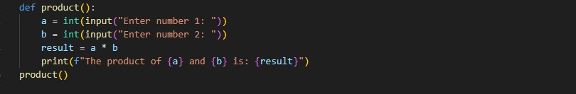

Output
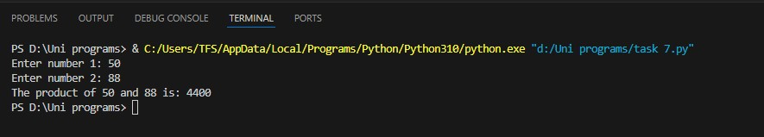
Task 2: Write a function that checks whether a number is even or odd.
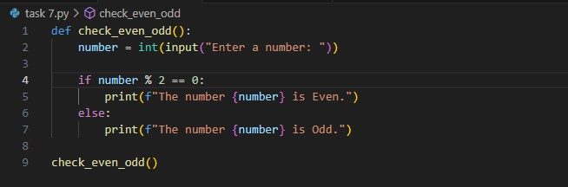

Output
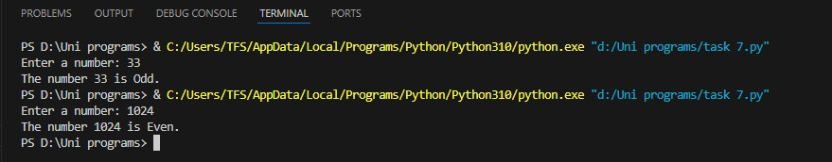
Task 3: Write a function that takes a name and age and prints a greeting message to the user
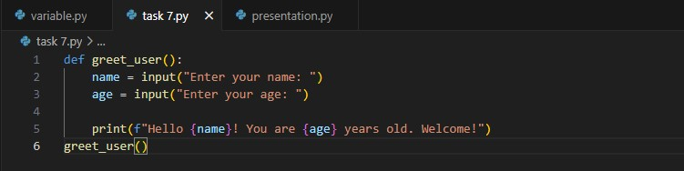

Output
